Answer: 0
------------------------------------------------------------------------------------------------------------------------------------------
What is the slope?
Line passes through: (0, -8) and (2, 6)

Answer: 7
------------------------------------------------------------------------------------------------------------------------------------------
What is the y-intercept?
y = 6

Answer: 6
------------------------------------------------------------------------------------------------------------------------------------------
True or False: The table below can be represented using the format y = kx.
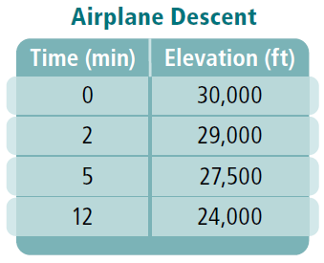
Answer: False
------------------------------------------------------------------------------------------------------------------------------------------
What is the y-intercept?
2y = 6x + 20

Answer: 10
------------------------------------------------------------------------------------------------------------------------------------------
What is the slope?
Line passes through: (-1, 3) and (0, 0)

Answer: -3
------------------------------------------------------------------------------------------------------------------------------------------
What is the y-intercept?
y = 3x + 2

Answer: 2
------------------------------------------------------------------------------------------------------------------------------------------
What is the constant of variation?
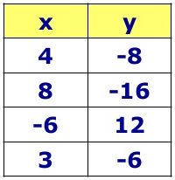

Answer: -2
------------------------------------------------------------------------------------------------------------------------------------------
What is the equation of a line with a y-intercept of 4 and a slope of ⁵/₂?

Answer: y = ⁵/₂x + 4
------------------------------------------------------------------------------------------------------------------------------------------
How is an equation using slope-intercept form written?

Answer: y = mx + b
------------------------------------------------------------------------------------------------------------------------------------------
Suppose y varies directly with x. If x = -5 and y = -15, what is the constant of variation?

Answer: 3
------------------------------------------------------------------------------------------------------------------------------------------
Suppose y varies directly with x. If x = 7.5 and y = 22.5, what is the equation to represent this relationship?

Answer: y = 3x
------------------------------------------------------------------------------------------------------------------------------------------
What is the equation of the following line?

Answer: y = 2x + 1
------------------------------------------------------------------------------------------------------------------------------------------
What is the slope?
-3y = 21x + 9

Answer: -7
------------------------------------------------------------------------------------------------------------------------------------------
What is the equation of a line that has a slope of 3 and goes through (0, 3)

Answer: y = 3x + 3
------------------------------------------------------------------------------------------------------------------------------------------
What is the equation of this direct variation?
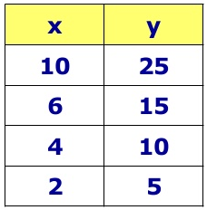
Answer: y = ⁵/₂x
------------------------------------------------------------------------------------------------------------------------------------------
True or False: The turtle is NOT traveling at a constant rate? (Hint: Is the rate of change constant?)
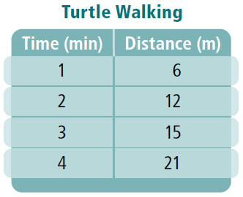

Answer: True
------------------------------------------------------------------------------------------------------------------------------------------
How is a direct variation written as an equation?

Answer: y = kx
------------------------------------------------------------------------------------------------------------------------------------------
What is the equation of the following line?

Answer: y = ¹/₂x + 1
------------------------------------------------------------------------------------------------------------------------------------------
Suppose y varies directly with x. Find the missing value if we know the following information:
(3, 4) (9, ?)

Answer: 12
------------------------------------------------------------------------------------------------------------------------------------------
What is the slope?
y = 6

Name: _____________________________________________________________ Period: ___________

Slope Quiz Review Trail

Answers:

Name: _____________________________________________________________ Period: ___________

Slope Quiz Review Trail

Answers:

