Name: _________________________________________________________________ Date: _________

Converting Units and Unit Rates HW
State Test Practice:
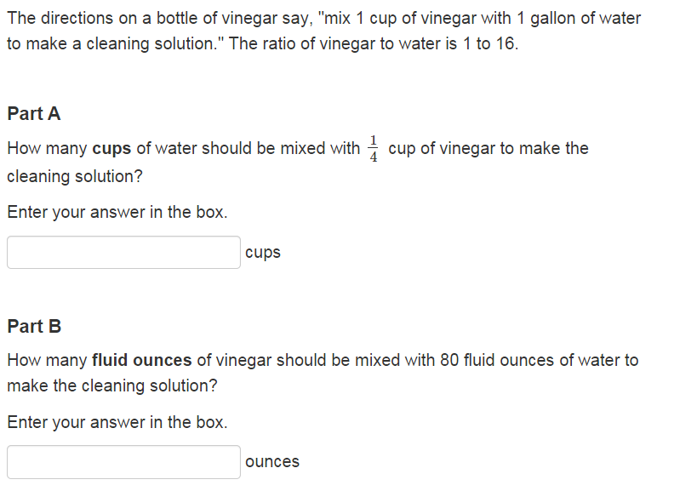
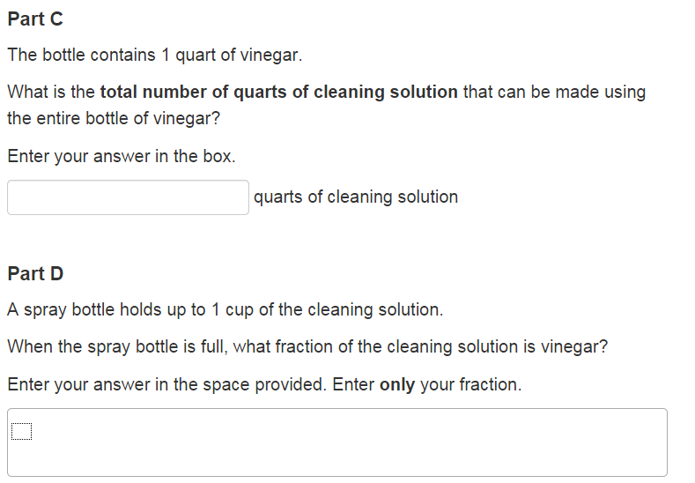
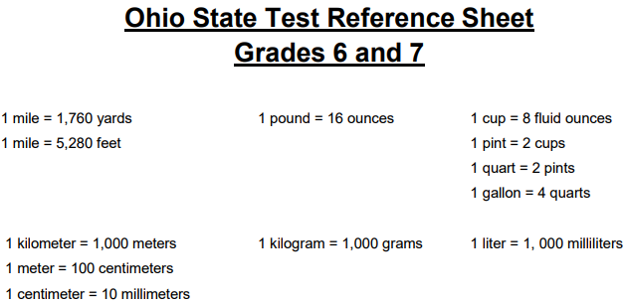
_____________________________________________________________________________________

Extra Practice:
1.) 18 quarts pints

2.) 295 gallons quarts

3.) 34 kilometers centimeters

4.) 50 cups per minute fluid ounces per second

5.) 65 miles per hour feet per minute

CHALLENGE:
522 quarts per centimeter cups per kilometer

