Name: ______________________________________________________________ Period: _________
Adding and Subtracting Integers Quiz Review Sheet

Review #1
X – Y = Z
If X > 0 and Y < 0, what must be true about Z?
- Positive
- Negative
- Positive or negative
- Zero

Review #2
How would you model 4 + (-6) using a number line?

How would you model 4 + (-6) using counters (chips)?

Review #3
Find the sum or difference.
-3 + (-7) = -9 – (-5) =

-26 + 19 = 46 – 54 =

Review #4
Find the absolute value.
-|4.5| |-3 + 6|

|8 – (-9)| -|-2|
Review #5
DAY | CHANGE IN DAILY HIGH TEMPERATURE
Monday | +7
Tuesday
Wednesday | -4
Thursday | +9
Friday | -15
Total | 3

Review #6
- What is p – n?
- What is n – p?
- Which is greater (p – n or n – p)?

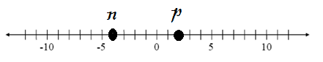

Additional Review Tips
Be sure to know…
- Adding integers rules
- Absolute value rules
- Definition of additive inverse
- Examples of opposites making zero
- Definition of an integer

