Name: ___________________________________________________________________ Period: _____
Independent Review
Solve for x.
1) -2x + 6 = -8 2) $\frac{x-5}{2}$ = -4

Solve for x.
3) 5(x + 5) = 85 4) -2x + 4 + 8x = -14

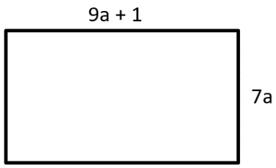
5) The perimeter of the rectangle is 66 units. Find the value of a.

------------------------------------------------------------- Checkpoint -------------------------------------------------------------
Write the inequality represented on each number line.
6) ____________________________ 7) ____________________________
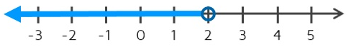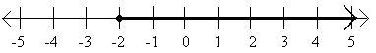

Solve for x. Then graph the solutions on the number line.
8) 4x + 3 > -5 9) 11 – 3x > 35

10) -6(2x – 4) < 36
------------------------------------------------------------- Checkpoint -------------------------------------------------------------
11) Brett has a $30 online gift voucher. He plans to buy as many books as he can. The cost of each book is $4. There is also a single shipping charge of $2. What is the maximum number of books he can buy without exceeding his gift voucher?

Inequality: _______________________________

Solution(s): _______________________________

12) Bert already has $50 but needs a total of at least $250 for his trip. He gets paid $12 per day for delivering papers. What is the least number of days he must work to get enough money for his trip?

Inequality: _______________________________

Solution(s): _______________________________

13) Chantelle has signed up for hockey. Her parents set a limit of $400 for costs for the season. It costs $250 to sign up plus $5 for each ice-time. What is the maximum number of ice-times that Chantelle can attend?

Inequality: _______________________________

Solution(s): _______________________________

14) Joe’s cell phone costs him $21 per month plus $3.50 for every 1GB of data downloaded. How many GBs can he download to stay within his monthly budget of $30?

Inequality: _______________________________

Solution(s): _______________________________
------------------------------------------------------------- Checkpoint -------------------------------------------------------------

