Name : _________________________________________________________ Period: ________

Unit 1 Test Review

1. Simplify the following:
a) 8 + (-12)
b) 2 – (-15)
c) -6 – 10
d) (-11) – (-4)

2. Simplify the following:
a) |-3|
b) -|3|
c) 10 + |-3|
d) 10 - |3|

3. Find each missing value below.
a) 12.4 + x = 0 b) 9 + x + (-3) = 0

c) -18 + 35 + x – 54 = 0 d) 0.8 + ³/₅ – ⁷/₁₀ – (-0.5) + x = 0

4. Find the difference between the following pairs of values:
a) 18 feet above sea level and 20 feet below sea level

b) A credit of $29.28 and a debit of $12.83

c) 45 degrees and 18 degrees below zero
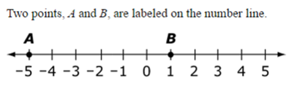
5.

What is the value of A?
What is the value of B?
What is the value of A + B?
What is the value of A – B?
What is the value of B – A?

7. Julie is reading her monthly bank account statement, which shows the following transactions.
What should his account balance read for this month?

$26.67, -$23.88, $45.91, -$18.37, $10.38

8. Fill each blank with a >, <, or =.
a) -5 + 5 6 – (-6)

b) |-8 + 4| |8 – 4|

c) -|24 – 8| -12 – 4

d) |-9| - (-2) -1 – (-12)

9. Find the distance between the following numbers. (Hint: |x – y|)
a) -2 and -4
b) -8 and 3
c) 14 and 87
d) -29 and 45
10. Find the missing values below.
a) If a – b = a + 9, what is the value of b?
b) If c + d = c – 2, what is the value of d?

11. Which number line model represents the sum of -¹/₂ + (-³/₂)?
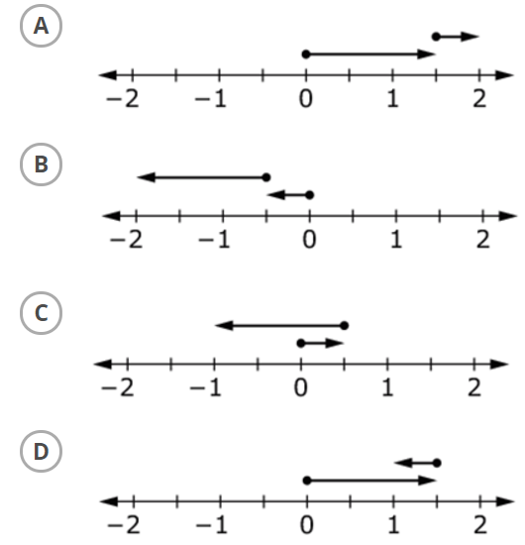

12. Find each sum.
a) 0.829 + 24.3 b) -53.87 + 97

13. Find each difference.
a) ³/₈ – 1³/₄ b) -⁴/₅ – ¹¹/₁₅

14. Find the distance between… A & B: ________ A & C: ________
