GREEN
1) Nicole and her brother ate an afternoon snack of popcorn when they came home from the park. Nicole ate $\frac{1}{2}$ cup of popcorn and her brother ate $\frac{1}{4}$ cup of popcorn. If there were $2\frac{2}{3}$ cups of popcorn in the container before their snack, how many cups were left after they finished? | 2) The difference between the lengths of a paddle boat and a pier is $-7\frac{3}{4}$feet. The pier is $18\frac{1}{2}$ feet long. How long is the paddle boat?
3) Mark, Gary, and Jill are on a family cell phone plan. They estimate that they have 7 hours of talk time for a weekend. Mark talked on his cell phone 2$\frac{5}{6}$ hours over the weekend. Gary talked on his phone 1$\frac{9}{10}$ hours. Jill talked on her cell phone for 1.5 hours. Did they go over 7 hours? If not, how many minutes do they have left to talk? | 4) Kari has a total of $12\frac{3}{4}$ yards of string for her craft project. She cuts 4.7 yards of string on the first day. The next day she uses $3\frac{1}{5}$ yards of string. She needs 4¼ yards of string to finish her project. Will she have enough string? If so, how much will she have left over? If not, how much string does she need?

Simplify each expression.
4) $\frac{9}{14}+\left(-\frac{2}{7}\right)$ | 5) $2\frac{5}{6}+\left(-\frac{8}{15}\right)$ | 6) $4+(-1\frac{2}{3})$
7) $-\frac{1}{2}-\left(-\frac{5}{9}\right)$ | 8) $-5-\frac{5}{3}$ | 9) $-8\frac{3}{8}-10\frac{1}{6}$
10) $2\frac{1}{6}—\frac{8}{3}+(-4\frac{7}{9})$ | 11) $-\frac{12}{5}+\left|-\frac{13}{6}\right|+(-3\frac{2}{3})$ | 12) $2\frac{3}{10}+\left(-3\frac{2}{5}\right)-(-\frac{9}{10})$

13) Check how one student solve this problem. Is it correct? If not, describe and correct the error.
$$\frac{3}{4}-\frac{9}{2}=\frac{3-9}{4-2}=\frac{-6}{2}=-3$$

EXTENSION
Write an equation and then solve using either fact families or inverse operations.
14) The difference between the lengths of a paddle boat and a pier is $-7\frac{3}{4}$feet. The pier is $18\frac{1}{2}$ feet long. How long is the paddle boat?

Solve each equation using either fact families or inverse operations.
15)$\frac{1}{2}=q+\frac{2}{3}$ | 16) $p-3\frac{1}{6}=-2\frac{1}{2}$
17) $-2\frac{1}{4}=r-\frac{4}{5}$ | 18)$w+3\frac{3}{8}=1\frac{5}{6}$
19) $4\frac{2}{5}+k=-3\frac{2}{11}$ | 20) $q+\frac{5}{9}=\frac{1}{6}$

YELLOW
$$-\frac{7}{8}+\frac{1}{4}$$ | 2)  $$\frac{1}{3}-(-\frac{1}{3})$$
3)  $$-6\frac{1}{3}+\frac{20}{3}$$ | 4)  $$-3\frac{1}{3}-\frac{5}{6}$$
5)  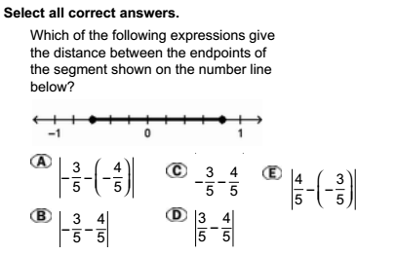  $$-2+\frac{7}{10}$$ | 6)  $$4\frac{1}{2}-5\frac{1}{4}$$
7)

1) Nicole and her brother ate an afternoon snack of popcorn when they came home from the park. Nicole ate $\frac{1}{2}$ cup of popcorn and her brother ate $\frac{1}{4}$ cup of popcorn. If there were $2\frac{2}{3}$ cups of popcorn in the container before their snack, how many cups were left after they finished? | 2) The difference between the lengths of a paddle boat and a pier is $-7\frac{3}{4}$feet. The pier is $18\frac{1}{2}$ feet long. How long is the paddle boat?
3) Mark, Gary, and Jill are on a family cell phone plan. They estimate that they have 7 hours of talk time for a weekend. Mark talked on his cell phone 2$\frac{5}{6}$ hours over the weekend. Gary talked on his phone 1$\frac{9}{10}$ hours. Jill talked on her cell phone for 1.5 hours. Did they go over 7 hours? If not, how many minutes do they have left to talk? | 4) Kari has a total of $12\frac{3}{4}$ yards of string for her craft project. She cuts 4.7 yards of string on the first day. The next day she uses $3\frac{1}{5}$ yards of string. She needs 4¼ yards of string to finish her project. Will she have enough string? If so, how much will she have left over? If not, how much string does she need?

Simplify each expression.
4) $\frac{9}{14}+\left(-\frac{2}{7}\right)$ | 5) $2\frac{5}{6}+\left(-\frac{8}{15}\right)$ | 6) $4+(-1\frac{2}{3})$
7) $-\frac{1}{2}-\left(-\frac{5}{9}\right)$ | 8) $-5-\frac{5}{3}$ | 9) $-8\frac{3}{8}-10\frac{1}{6}$
10) $2\frac{1}{6}—\frac{8}{3}+(-4\frac{7}{9})$ | 11) $-\frac{12}{5}+\left|-\frac{13}{6}\right|+(-3\frac{2}{3})$ | 12) $2\frac{3}{10}+\left(-3\frac{2}{5}\right)-(-\frac{9}{10})$

13) Check how one student solve this problem. Is it correct? If not, describe and correct the error.
$$\frac{3}{4}-\frac{9}{2}=\frac{3-9}{4-2}=\frac{-6}{2}=-3$$

RED
$$-\frac{5}{8}+\frac{11}{12}$$  Common Denominator: Yes or No  If no,  Multiples of 8: 8, 16, 24, 32, 40  Multiples of 12: 12, 24, 36  LCD = _______  Change Fraction:  Simplify: | 2)  $$\frac{1}{3}-(-\frac{1}{3})$$  Common Denominator: Yes or No  If no,  Multiples of 3:  Multiples of 3:  LCD = _________  Change Fraction:  Simplify:
3)  $$-\frac{7}{8}+\frac{1}{4}$$  Common Denominator: Yes or No  If no,  Multiples of 4:  Multiples of 8:  LCD = _________  Change Fraction:  Simplify: | 4)  $$-3\frac{1}{3}-\frac{5}{6}$$  Common Denominator: Yes or No  If no,  Multiples of 3:  Multiples of 6:  LCD = _________  Change to Improper:  Change Fraction:  Simplify:
5)  $$-2+\frac{7}{10}$$  Common Denominator: Yes or No  If no,  Multiples of 1 (because 2 = 2/1):  Multiples of 10:  LCD = _________  Change Fraction:  Simplify: | 6)  $$4\frac{1}{2}-5\frac{1}{4}$$  Common Denominator: Yes or No  If no,  Multiples of 2:  Multiples of 4:  LCD = _________  Change to Improper:  Change Fraction:  Simplify:

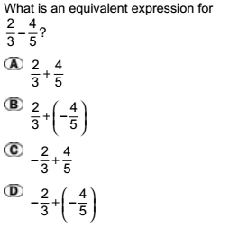
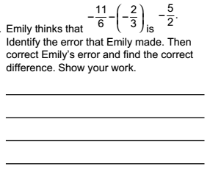
7) 8)

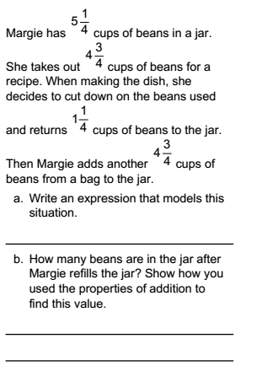

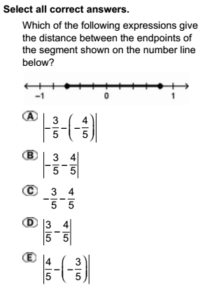
9) 10)

