Name : __________________________________________________________________________ Period: ___________

Number Properties: Identify and Apply

Part 1: Identify the property described.

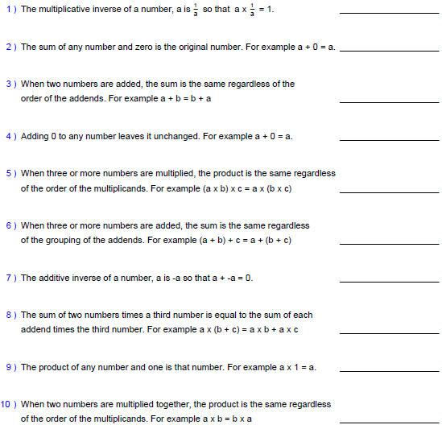

(MORE ON BACK)
Part 2: Provide the property used during each step of the problems below.

11) 3(20 + 7) - 2( ½ ) + 8(1)
___________________________________
60 + 21 - 2( ½ ) + 8(1)
___________________________________
60 + 21 – 1 + 8(1)
___________________________________
60 + 21 – 1 + 8

______________ (What is simplified expression?)

12) (-4 + 11) + (-16 + 9) + 5(0)
___________________________________
(-4 + -16) + (11 + 9) + 5(0)
___________________________________
-20 + 20 + 0
___________________________________
0 + 0
___________________________________
0

Part 3: Solve for the given variable.

13) What is a? 3(a + 7) = -9 + 21 14) What is b? 4b + 8b + 12b = 0

15) What is c? 18 + c + 7 = 7 + 18 + 9 16) What is d? (d + 5) + 10 = 20 + (5 + 10)

